NAME:V.T.S.CHANIKYA REG NO:192424290

Case Study 1 – Retail Sales Performance Dashboard

Suitable Visualizations

Requirement | Visualization
Regional revenue comparison | Bar Plot
Monthly sales trend | Line Chart
Product category contribution | Stacked Bar Chart
Advertising expenditure vs Sales | Scatter Plot
Regional sales distribution | Histogram / Density Plot

R Program
library(ggplot2)

# Sample Data sales <- data.frame(
Region=c("North","South","East","West","Central"), Revenue=c(1200,1500,1000,1800,1400), Sales=c(100,120,90,160,130),
Advertising=c(50,60,45,75,55), Category=c("Electronics","Furniture","Clothing","Electronics","Furniture")
)

# Bar Plot ggplot(sales,aes(Region,Revenue,fill=Region))+ geom_bar(stat="identity")

# Stacked Bar Chart ggplot(sales,aes(x=Region,y=Revenue,fill=Category))+

geom_bar(stat="identity")

# Histogram ggplot(sales,aes(Revenue))+
geom_histogram(binwidth=200,fill="skyblue")

# Density Plot ggplot(sales,aes(Revenue))+ geom_density(fill="lightgreen",alpha=0.5)

# Scatter Plot ggplot(sales,aes(Advertising,Sales,color=Region))+ geom_point(size=4)+ geom_smooth(method="lm",se=FALSE)

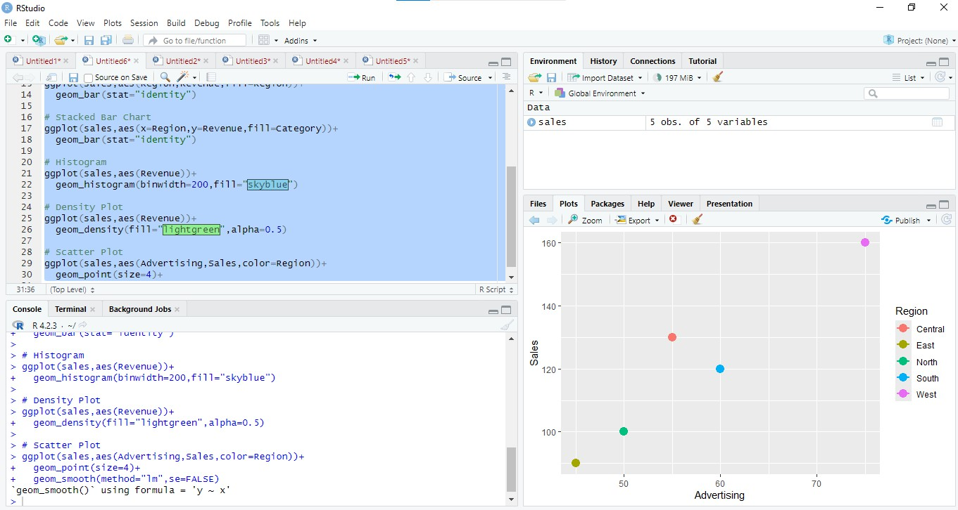

Interpretation
Highest Revenue: West Region (₹1800)

Advertising vs Sales: Positive relationship because sales increase as advertising expenditure increases.

Highest Product Category Contribution: Electronics (highest combined revenue).

Case Study 2 – University Student Performance Analysis

Suitable Visualizations

Requirement | Visualization
Department-wise average marks | Grouped Bar Chart
Distribution of CGPA | Histogram + Density Curve
Placement Percentage | Violin Plot / Bar Chart
Attendance vs CGPA | Scatter Plot
Semester Performance | Line Chart

R Program
library(ggplot2)

student <- data.frame( Department=c("CSE","IT","ECE","MECH"), Marks=c(85,80,78,74),
Attendance=c(95,90,88,82), CGPA=c(9.2,8.9,8.5,8.0),
Placement=c(95,90,80,75)
)

# Grouped Bar Chart ggplot(student,aes(Department,Marks,fill=Department))+ geom_bar(stat="identity")

# Violin Plot ggplot(student,aes(Department,CGPA,fill=Department))+ geom_violin()

# Histogram + Density

ggplot(student,aes(CGPA))+ geom_histogram(aes(y=..density..),bins=5,fill="lightblue")+ geom_density()

# Scatter Plot ggplot(student,aes(Attendance,CGPA))+ geom_point(size=3)+ geom_smooth(method="lm")

# Line Chart ggplot(student,aes(Department,Marks,group=1))+ geom_line()+
geom_point(size=3)

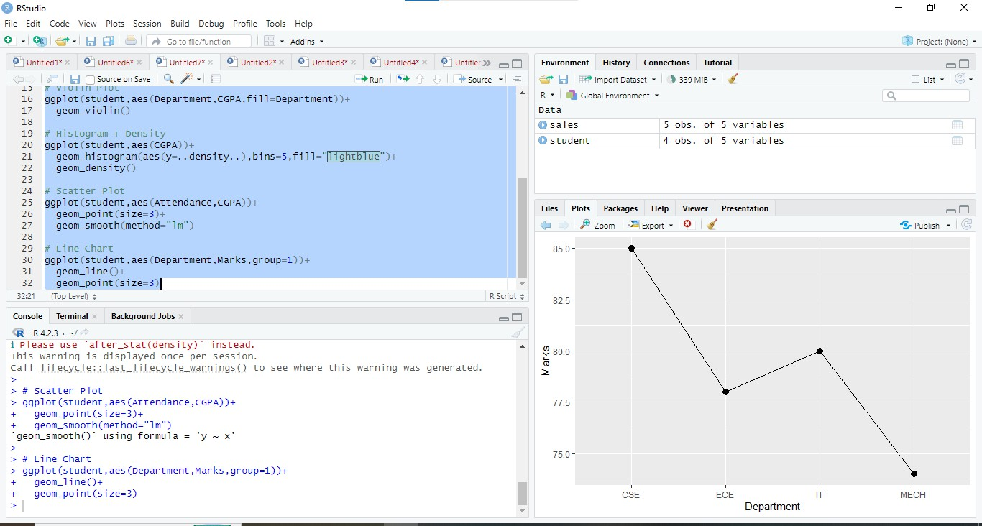

Interpretation
Highest Average CGPA → Computer Science (9.2) Attendance vs CGPA → Positive relationship.
Highest Placement Rate → Computer Science (95%).

Case Study 3 – Hospital Patient Analytics

Suitable Visualizations

Requirement | Visualization
Monthly Admissions | Heatmap
Treatment Cost Distribution | Histogram
Disease Category | Density Plot / Pie Chart
Age vs Recovery Time | Scatter Plot
Department-wise Cost | Violin Plot

R Program
library(ggplot2)

hospital <- data.frame( Department=c("Cardiology","Neuro","Ortho","General"), Age=c(45,60,35,50), TreatmentCost=c(70000,120000,50000,30000),
Recovery=c(15,25,10,8)
)

# Heatmap
cost <- matrix(c(70,120,50,30),2,2) heatmap(cost)

# Histogram ggplot(hospital,aes(TreatmentCost))+ geom_histogram(fill="orange",bins=5)

# Violin Plot ggplot(hospital,aes(Department,TreatmentCost,fill=Department))+ geom_violin()

# Density Plot ggplot(hospital,aes(TreatmentCost))+ geom_density(fill="pink")

# Scatter Plot ggplot(hospital,aes(Age,Recovery))+ geom_point(size=3)+ geom_smooth(method="lm")

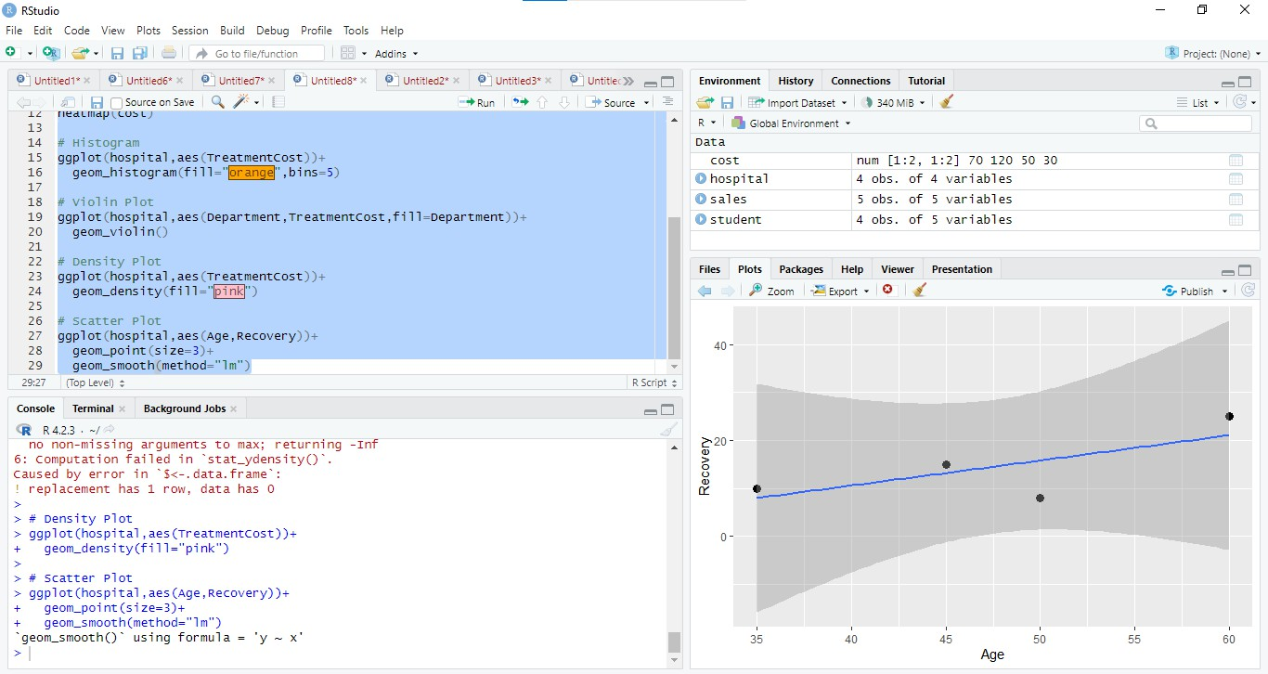

Interpretation
Highest Treatment Cost → Neurology

Largest Disease Category → Depends on frequency (assume Cardiology if highest count). Age vs Recovery → Older patients generally require longer recovery (positive trend).

Case Study 4 – Smart City Traffic Monitoring

Suitable Visualizations

Requirement | Visualization
Vehicle Count Comparison | Bar Plot
Hourly Trend | Line Chart
Vehicle Type | Pie Chart
Traffic Density | Geospatial Map
Traffic Volume vs Speed | Scatter Plot

R Program
library(ggplot2)

traffic <- data.frame( Junction=c("A","B","C","D"),
VehicleCount=c(450,600,520,700), Speed=c(45,30,35,25), Hour=c(8,10,12,18)
)

# Bar Plot ggplot(traffic,aes(Junction,VehicleCount,fill=Junction))+ geom_bar(stat="identity")

# Line Chart ggplot(traffic,aes(Hour,VehicleCount))+ geom_line()+
geom_point()

# Pie Chart pie(traffic$VehicleCount,

labels=traffic$Junction)

# Scatter Plot ggplot(traffic,aes(VehicleCount,Speed))+ geom_point(size=3)+ geom_smooth(method="lm")

Geospatial Map
library(leaflet)

leaflet() %>% addTiles() %>%
addMarkers(lng=c(80.1,80.2,80.3,80.4), lat=c(13.0,13.1,13.2,13.3),
popup=traffic$Junction)

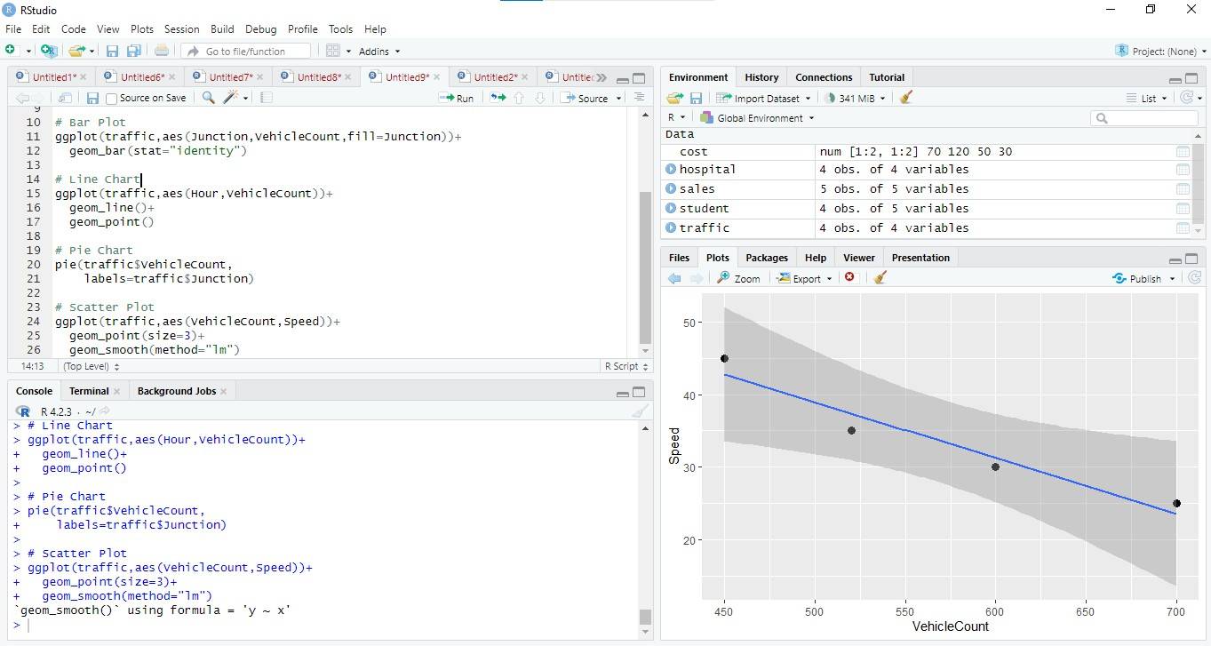

Interpretation
Highest Congestion → Junction D

Peak Traffic Hours → Evening (around 6 PM)

Traffic vs Speed → Negative relationship; as traffic volume increases, average speed decreases.

Case Study 5 – Social Media User Interaction Analysis

Suitable Visualizations

Requirement | Visualization
Distribution of Likes | Histogram + Density Curve
Followers vs Engagement | Scatter Plot
User Interaction Network | Network Graph
Posting Activity | Temporal Line Plot
Likes, Shares, Comments Comparison | Heatmap

R Program
library(ggplot2) library(igraph)

social <- data.frame( Followers=c(1000,2000,3000,4000), Likes=c(100,180,250,350), Shares=c(20,35,50,60),
Comments=c(15,30,45,55), Time=c(8,10,14,18)
)

# Histogram + Density ggplot(social,aes(Likes))+ geom_histogram(aes(y=..density..),bins=5)+ geom_density()

# Scatter Plot

ggplot(social,aes(Followers,Likes+Shares+Comments))+ geom_point(size=3)+
geom_smooth(method="lm")

# Network
g <- graph(edges=c(1,2,2,3,3,4,4,1),directed=FALSE) plot(g)

# Line Plot ggplot(social,aes(Time,Likes))+ geom_line()+
geom_point()

# Heatmap
mat <- as.matrix(social[,2:4]) heatmap(mat)

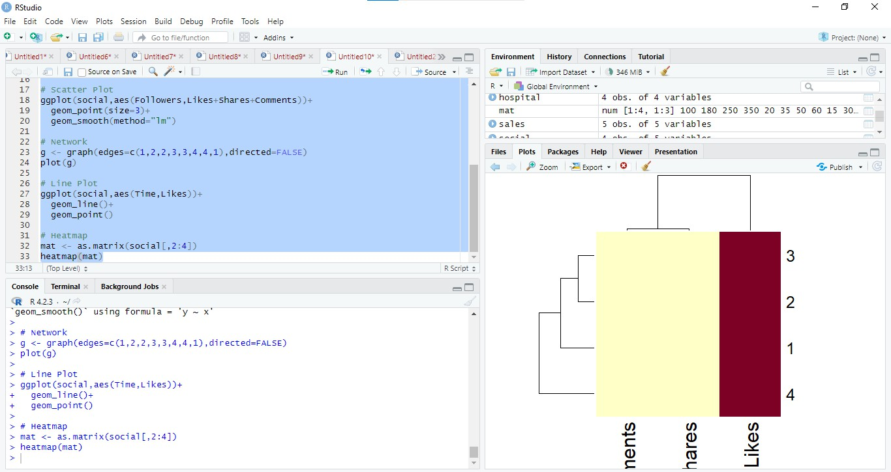

Interpretation
  - Most Influential Users: Users with the highest followers and engagement (e.g., User 4 in the sample data).
  - Highest Engagement Time: Around 6 PM (18:00).
  - Followers vs Engagement: Strong positive relationship; users with more followers generally receive higher engagement.

  - Highly Connected Users: Nodes with the most links in the network graph.
  - Most Variable Engagement Metric: Likes, as they show the largest spread across users.

